**ADDITIONAL NEURAL NETWORK CONCEPTS**

**ADVANCED OPTIMIZATION**

**Understanding Gradient Descent**

* **Gradient descent is a foundational optimization algorithm used in machine learning for minimizing cost functions, but it can be slow and inefficient in certain scenarios.**
* **The algorithm updates parameters by taking steps proportional to the negative of the gradient, but the choice of learning rate can significantly affect performance.**

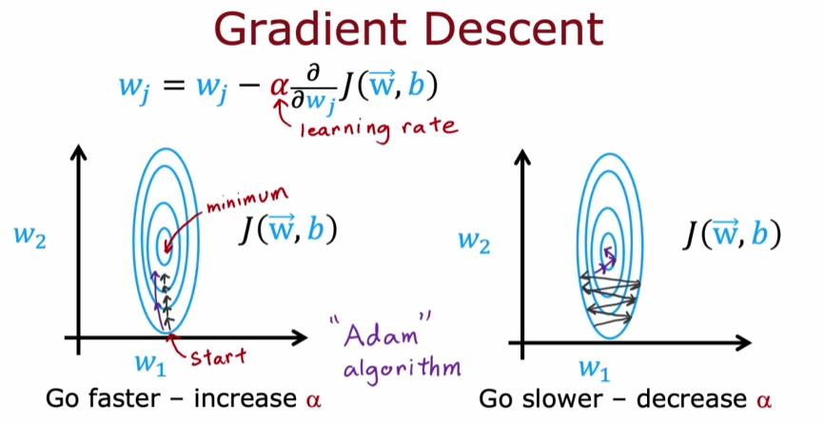

**The Adam Algorithm**

* **Adam stands for Adaptive Moment Estimation and adapts the learning rate for each parameter individually, allowing for faster convergence.**
* **It automatically increases the learning rate when parameters move consistently in one direction and decreases it when oscillation occurs, optimizing the training process.**

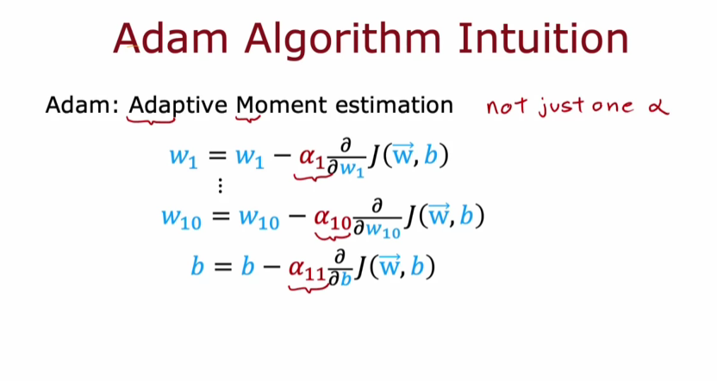

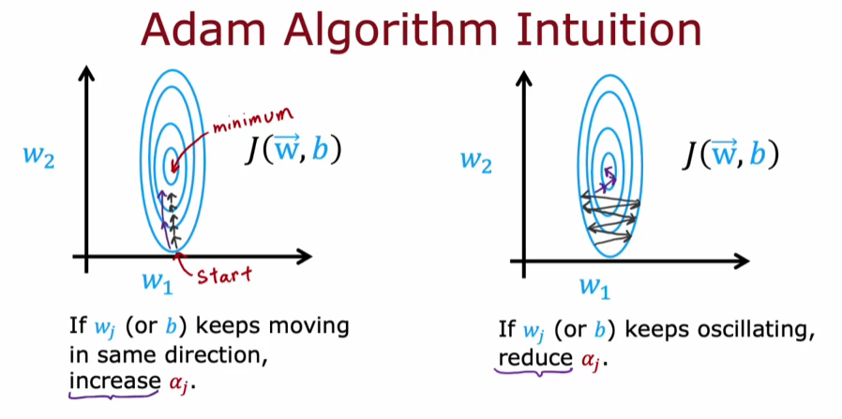

**ADDITIONAL LAYER TYPES**

**Understanding Dense and Convolutional Layers**

* **Dense layers connect every neuron in one layer to every neuron in the next, allowing for powerful learning algorithms.**
* **Convolutional layers, on the other hand, allow neurons to focus on specific regions of the input, which can enhance efficiency and reduce the need for extensive training data.**

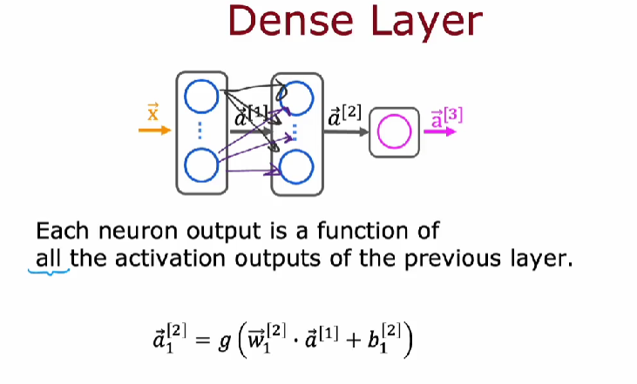

**Benefits of Convolutional Layers**

* **They speed up computation by limiting the number of inputs each neuron processes.**
* **Convolutional layers are less prone to overfitting, making them suitable for applications with limited training data.**

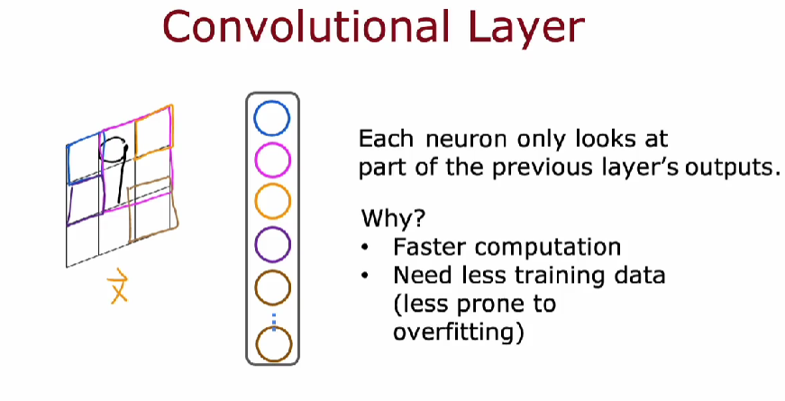

**Applications of Convolutional Neural Networks**

* **Convolutional layers can be used in various applications, such as image recognition and time-series classification, like analyzing EKG signals for heart disease diagnosis.**
* **The architecture of convolutional networks can be customized by adjusting parameters like the size of the input window and the number of neurons.**

